**ML Tutorial**

**DataSet**

**Q1 ) Decision Tree**

**Output:**

**R Programming**

**Code :**

# Load required libraries

library(rpart)

library(rpart.plot)

library(caret)

# Load dataset

file_path <- "C:/Users/Sanjay/Desktop/ML Tutorial/archive/laptop_prices.csv" # Updated file path

data <- read.csv(file_path)

# View dataset structure

str(data)

print(colnames(data)) # Check column names to avoid errors

# Handle column name issues

colnames(data) <- gsub("[^[:alnum:]_]", "_", colnames(data)) # Fix special characters in column names

# Convert categorical columns to factors

data$Brand <- as.factor(data$Brand)

data$Processor <- as.factor(data$Processor)

data$GPU <- as.factor(data$GPU)

data$Operating_System <- as.factor(data$Operating_System)

# Convert Storage to numeric

data$Storage <- as.numeric(gsub("[^0-9]", "", data$Storage))

# Convert Resolution to total pixel count

resolution_split <- strsplit(as.character(data$Resolution), "x")

data$Total_Pixels <- sapply(resolution_split, function(x) as.numeric(x[1]) * as.numeric(x[2]))

# Remove unnecessary columns

data <- subset(data, select = -c(Resolution))

# Remove missing values

data <- na.omit(data)

# Ensure target variable is numeric

data$Price <- as.numeric(data$Price)

# Split dataset into training and testing (80-20 split)

set.seed(42)

split <- createDataPartition(data$Price, p = 0.8, list = FALSE)

train_data <- data[split, ]

test_data <- data[-split, ]

# Train Decision Tree Model

decision_tree_model <- rpart(Price ~ ., data = train_data, method = "anova")

# Visualize Decision Tree

rpart.plot(decision_tree_model, main = "Decision Tree for Laptop Prices", type = 3, extra = 101)

# Make Predictions

predictions <- predict(decision_tree_model, test_data)

# Evaluate Model Performance

mse <- mean((test_data$Price - predictions)^2)

rmse <- sqrt(mse)

r2 <- 1 - (sum((test_data$Price - predictions)^2) / sum((test_data$Price - mean(test_data$Price))^2))

# Calculate Accuracy (Custom Approach)

tolerance <- 0.1 * test_data$Price # 10% tolerance

correct_predictions <- abs(test_data$Price - predictions) <= tolerance

accuracy <- mean(correct_predictions) * 100 # Convert to percentage

# Print Final Accuracy Metrics

cat("\n===== Final Model Evaluation Metrics =====\n")

cat(sprintf(" Mean Squared Error (MSE): %.2f\n", mse))

cat(sprintf(" Root Mean Squared Error (RMSE): %.2f\n", rmse))

cat(sprintf(" R-squared (R²): %.4f\n", r2))

cat(sprintf(" Model Accuracy: %.2f%%\n", accuracy))

**Output:**

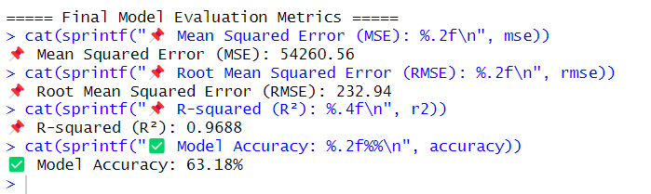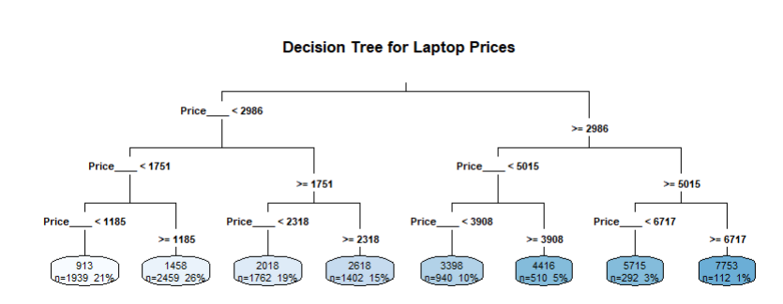

**Python**

**Code :**

*import* pandas *as* pd

*import* numpy *as* np

*import* matplotlib.pyplot *as* plt

*from* sklearn.model_selection *import* train_test_split

*from* sklearn.preprocessing *import* LabelEncoder

*from* sklearn.tree *import* DecisionTreeRegressor, plot_tree

*from* sklearn.metrics *import* mean_squared_error, r2_score

*# Load dataset*

file_path = *r*"C:\Users\Sanjay\Desktop\ML Tutorial\archive\laptop_prices.csv"

df = pd.read_csv(file_path)

*# Convert Storage to numerical format (handling missing values)*

df['Storage'] = df['Storage'].str.extract(*r*'(\d+)').dropna().astype(float)

*# Convert Resolution to total pixel count*

df[['Width', 'Height']] = df['Resolution'].str.split('x', expand=True).astype(float)

df['Total_Pixels'] = df['Width'] * df['Height']

df.drop(columns=['Resolution', 'Width', 'Height'], inplace=True

*# Encode categorical variables*

label_encoders = {}

*for* col *in* ['Brand', 'Processor', 'GPU', 'Operating System']:

    le = LabelEncoder()

    df[col] = le.fit_transform(df[col])

    label_encoders[col] = le

*# Define features and target variable*

X = df.drop(columns=['Price ($)'])

y = df['Price ($)']

*# Split dataset into training and testing sets*

X_train, X_test, y_train, y_test = train_test_split(X, y, test_size=0.2, random_state=42)

*# Train Decision Tree Regressor*

dt_model = DecisionTreeRegressor(random_state=42, max_depth=5)

dt_model.fit(X_train, y_train)

*# Predictions*

y_pred = dt_model.predict(X_test)

*# Evaluate the model*

mse = mean_squared_error(y_test, y_pred)

r2 = r2_score(y_test, y_pred)

*# Calculate accuracy as percentage of predictions within 10% tolerance of actual values*

tolerance = 0.1 * y_test  *# 10% of actual price*

correct_predictions = np.abs(y_test - y_pred) <= tolerance

accuracy = np.mean(correct_predictions) * 100  *# Convert to percentage*

*# Print evaluation metrics*

print(*f*"MSE: {mse*:.2f*}")

print(*f*"R² Score: {r2*:.4f*}")

print(*f*"Accuracy: {accuracy*:.2f*}%")  *# Display accuracy percentage*

*# Visualize the decision tree*

plt.figure(figsize=(20, 10))

plot_tree(dt_model, feature_names=X.columns, filled=True, rounded=True, fontsize=10)

plt.show()

**Output:**

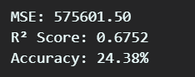

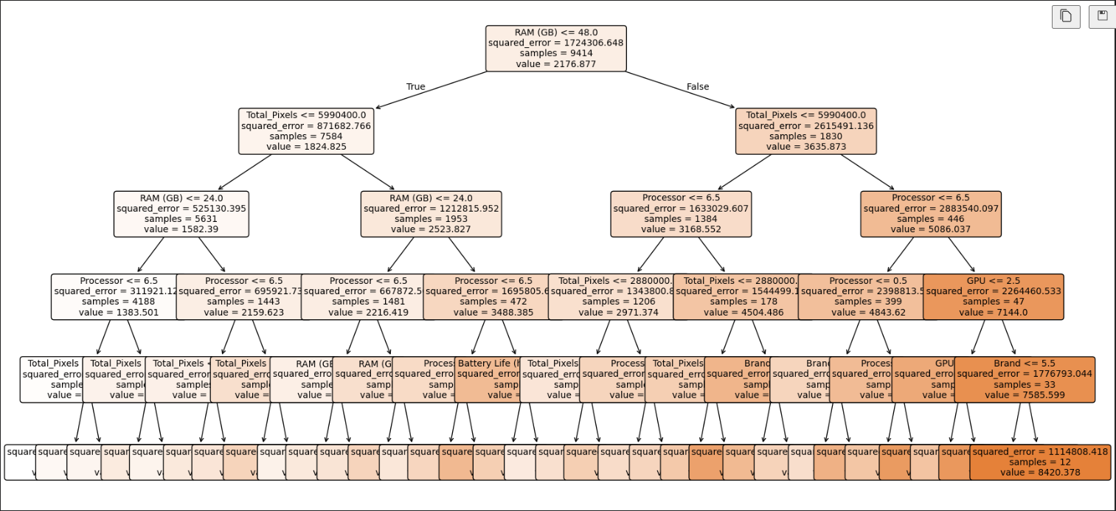

**Q2 ) Navie Bayes**

**Weka**

**Output:**

**R Programming**

Code :

# Load required libraries

library(e1071)

library(caret)

library(dplyr)

# Load dataset

file_path <- "C:/Users/Sanjay/Desktop/ML Tutorial/archive/laptop_prices.csv"

df <- read.csv(file_path, stringsAsFactors = TRUE)

# Check actual column names

print(colnames(df)) # Check column names before processing

# Fix column names (replace spaces and special characters)

colnames(df) <- gsub("[^[:alnum:]_]", "_", colnames(df))

# Identify the actual column name for price

price_col <- grep("Price", colnames(df), value = TRUE) # Find column with "Price"

if (length(price_col) == 0) {

stop(" Error: No column related to 'Price' found in the dataset.")

} else {

cat(" Found Price column:", price_col, "\n")

}

# Convert categorical variables to factors

df$Brand <- as.factor(df$Brand)

df$Processor <- as.factor(df$Processor)

df$GPU <- as.factor(df$GPU)

df$Operating_System <- as.factor(df$Operating_System)

# Convert Storage to numeric (extract digits)

df$Storage <- as.numeric(gsub("[^0-9]", "", df$Storage))

# Convert Resolution to total pixel count

resolution_split <- strsplit(as.character(df$Resolution), "x")

df$Total_Pixels <- sapply(resolution_split, function(x) as.numeric(x[1]) * as.numeric(x[2]))

# Drop unnecessary columns

df <- df %>% select(-Resolution)

# Handle missing values

df <- na.omit(df)

# Convert Price to categorical variable (Low, Medium, High)

df$Price_Category <- cut(df[[price_col]], # Use dynamic column name

breaks = quantile(df[[price_col]], probs = c(0, 1/3, 2/3, 1), na.rm = TRUE),

labels = c("Low", "Medium", "High"),

include.lowest = TRUE)

# Remove original Price column

df<- df %>% select(-all_of(price_col))

# Split dataset into training and testing

set.seed(42)

split_index <- createDataPartition(df$Price_Category, p = 0.8, list = FALSE)

train_data <- df[split_index, ]

test_data <- df[-split_index, ]

# Train Naïve Bayes Classifier

nb_model <- naiveBayes(Price_Category ~ ., data = train_data)

# Predictions

predictions <- predict(nb_model, test_data)

# Model Evaluation

accuracy <- mean(predictions == test_data$Price_Category)

cat(sprintf(" Model Accuracy: %.2f%%\n", accuracy * 100))

# Confusion Matrix

cat("\n Confusion Matrix:\n")

print(confusionMatrix(predictions, test_data$Price_Category))

**Output:**

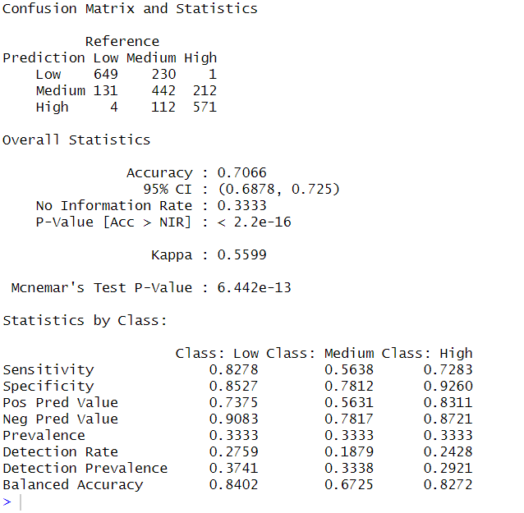

**Python**

Code :

*import* pandas *as* pd

*import* numpy *as* np

*import* matplotlib.pyplot *as* plt

*from* sklearn.model_selection *import* train_test_split

*from* sklearn.preprocessing *import* LabelEncoder, StandardScaler

*from* sklearn.naive_bayes *import* GaussianNB

*from* sklearn.metrics *import* accuracy_score, classification_report, confusion_matrix

*# Load dataset*

file_path = *r*"C:\Users\Sanjay\Desktop\ML Tutorial\archive\laptop_prices.csv"

df = pd.read_csv(file_path)

*# Convert Storage to numerical format (handling missing values)*

df['Storage'] = df['Storage'].str.extract(*r*'(\d+)').dropna().astype(float)

*# Convert Resolution to total pixel count*

df[['Width', 'Height']] = df['Resolution'].str.split('x', expand=True).astype(float)

df['Total_Pixels'] = df['Width'] * df['Height']

df.drop(columns=['Resolution', 'Width', 'Height'], inplace=True)

*# Encode categorical variables*

label_encoders = {}

*for* col *in* ['Brand', 'Processor', 'GPU', 'Operating System']:

    le = LabelEncoder()

    df[col] = le.fit_transform(df[col])

    label_encoders[col] = le

*# Convert price into categories (Low, Medium, High)*

df['Price Category'] = pd.qcut(df['Price ($)'], q=3, labels=['Low', 'Medium', 'High'])

*# Define features and target variable*

X = df.drop(columns=['Price ($)', 'Price Category'])

y = df['Price Category']

*# Standardize features*

scaler = StandardScaler()

X_scaled = scaler.fit_transform(X)

*# Split dataset into training and testing sets*

X_train, X_test, y_train, y_test = train_test_split(X_scaled, y, test_size=0.2, random_state=42)

*# Train Naive Bayes Classifier*

nb_model = GaussianNB()

nb_model.fit(X_train, y_train)

*# Predictions*

y_pred = nb_model.predict(X_test)

*# Evaluate the model*

accuracy = accuracy_score(y_test, y_pred)

print(*f*"Accuracy: {accuracy*:.2f*}")

print("\nClassification Report:")

print(classification_report(y_test, y_pred))

*# Confusion matrix*

conf_matrix = confusion_matrix(y_test, y_pred)

print("\nConfusion Matrix:")

print(conf_matrix)

**Output:**

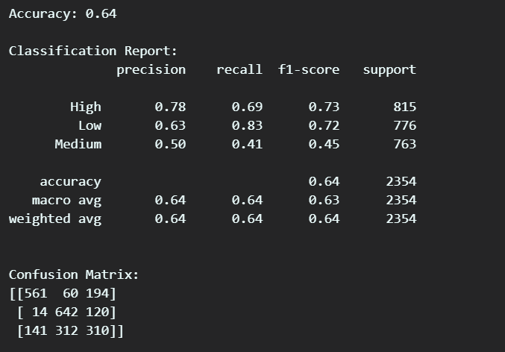

**Q3 ) KNN**

**Weka**

**Output:**

**R Programming**

Code :

# Load required libraries (install only if missing)

packages <- c("tidyverse", "class", "caret", "ggplot2")

install_if_missing <- function(pkg) {

if (!require(pkg, character.only = TRUE)) install.packages(pkg, dependencies = TRUE)

library(pkg, character.only = TRUE)

}

lapply(packages, install_if_missing)

# Load dataset

file_path <- "C:/Users/Sanjay/Desktop/ML Tutorial/archive/laptop_prices.csv"

df <- read.csv(file_path, stringsAsFactors = FALSE)

# Print column names to verify structure

print("Column names in dataset:")

print(colnames(df))

# Ensure Operating System column exists

actual_os_col <- colnames(df)[grepl("Operating", colnames(df), ignore.case = TRUE)]

if (length(actual_os_col) == 0) {

stop("Error: Column related to Operating System not found in dataset. Check column names.")

} else {

colnames(df)[colnames(df) == actual_os_col] <- "Operating_System"

}

# Ensure Price column exists

actual_price_col <- colnames(df)[grepl("Price", colnames(df), ignore.case = TRUE)]

if (length(actual_price_col) == 0) {

stop("Error: Column related to Price not found in dataset. Check column names.")

} else {

colnames(df)[colnames(df) == actual_price_col] <- "Price"

}

# Ensure Storage is numeric (remove non-numeric characters)

df$Storage <- as.numeric(gsub("[^0-9]", "", df$Storage))

# Convert Resolution to total pixel count (if column exists)

if ("Resolution" %in% colnames(df)) {

resolution_split <- strsplit(as.character(df$Resolution), "x")

df$Total_Pixels <- sapply(resolution_split, function(x) as.numeric(x[1]) * as.numeric(x[2]))

df <- df %>% select(-Resolution) # Remove original Resolution column

}

# Print first few rows to check structure

print(head(df))

# Handle missing values before encoding

df <- df %>% drop_na(Brand, Processor, GPU, Operating_System, Price)

# Encode categorical variables

df$Brand <- as.factor(df$Brand)

df$Processor <- as.factor(df$Processor)

df$GPU <- as.factor(df$GPU)

df$Operating_System <- as.factor(df$Operating_System)

# Convert Price into categories (Low, Medium, High)

df$Price_Category <- cut(df$Price,

breaks = quantile(df$Price, probs = seq(0, 1, by = 1/3), na.rm = TRUE),

labels = c("Low", "Medium", "High"),

include.lowest = TRUE)

# Remove rows with missing values

df <- na.omit(df)

# Define features (X) and target variable (y)

X <- df %>% select(-c(Price, Price_Category))

# Fix: Select only numeric columns for scaling

X_numeric <- X %>% select(where(is.numeric))

# Check column types

print("Checking feature data types:")

print(str(X_numeric))

# Normalize features

X_scaled <- as.data.frame(scale(X_numeric))

# Split dataset into training and testing sets (80% train, 20% test)

set.seed(42)

train_indices <- createDataPartition(df$Price_Category, p = 0.8, list = FALSE)

X_train <- X_scaled[train_indices, ]

X_test <- X_scaled[-train_indices, ]

train_labels <- df$Price_Category[train_indices]

test_labels <- df$Price_Category[-train_indices]

# Ensure labels are factors with the same levels

train_labels <- factor(train_labels)

test_labels <- factor(test_labels, levels = levels(train_labels))

# Train KNN model with k=5

k <- 5

knn_pred <- knn(train = X_train, test = X_test, cl = train_labels, k = k)

# Evaluate model performance

accuracy <- mean(knn_pred == test_labels) * 100

cat("KNN Model Accuracy:", round(accuracy, 2), "%\n")

# Confusion matrix

conf_matrix <- confusionMatrix(knn_pred, test_labels)

print(conf_matrix)

# Plot accuracy for different K values

k_values <- seq(1, 20, by = 1)

accuracies <- sapply(k_values, function(k) {

pred_k <- knn(train = X_train, test = X_test, cl = train_labels, k = k)

mean(pred_k == test_labels)

})

# Plot the KNN accuracy curve

ggplot(data.frame(K = k_values, Accuracy = accuracies), aes(x = K, y = Accuracy)) +

geom_line(color = "blue") +

geom_point(color = "red") +

ggtitle("K-Value vs Accuracy for KNN") +

xlab("Number of Neighbors (K)") +

ylab("Accuracy") +

theme_minimal()

**Output:**

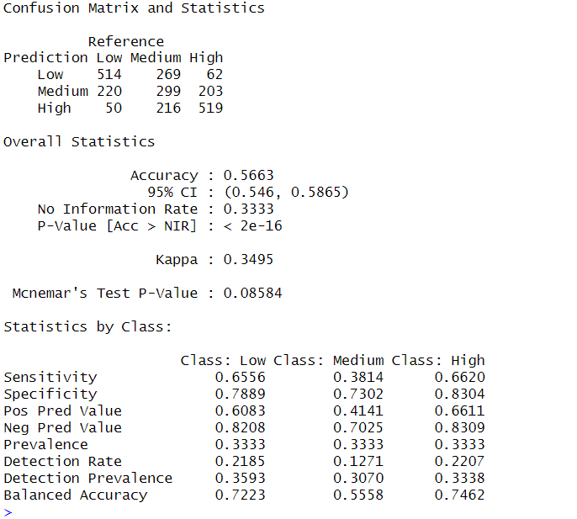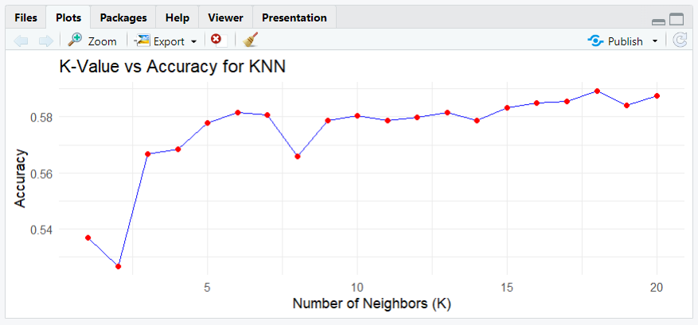

**Python**

**Code :**

*import* pandas *as* pd

*import* numpy *as* np

*import* matplotlib.pyplot *as* plt

*from* sklearn.model_selection *import* train_test_split

*from* sklearn.preprocessing *import* LabelEncoder, StandardScaler

*from* sklearn.neighbors *import* KNeighborsClassifier

*from* sklearn.metrics *import* accuracy_score, classification_report, confusion_matrix

*# Load dataset*

file_path = *r*"C:\Users\Sanjay\Desktop\ML Tutorial\archive\laptop_prices.csv"

df = pd.read_csv(file_path)

*# Convert Storage to numerical format (handling missing values)*

df['Storage'] = df['Storage'].str.extract(*r*'(\d+)').dropna().astype(float)

*# Convert Resolution to total pixel count*

df[['Width', 'Height']] = df['Resolution'].str.split('x', expand=True).astype(float)

df['Total_Pixels'] = df['Width'] * df['Height']

df.drop(columns=['Resolution', 'Width', 'Height'], inplace=True)

*# Encode categorical variables*

label_encoders = {}

*for* col *in* ['Brand', 'Processor', 'GPU', 'Operating System']:

    le = LabelEncoder()

    df[col] = le.fit_transform(df[col])

    label_encoders[col] = le

*# Convert price into categories (Low, Medium, High)*

df['Price Category'] = pd.qcut(df['Price ($)'], q=3, labels=['Low', 'Medium', 'High'])

*# Define features and target variable*

X = df.drop(columns=['Price ($)', 'Price Category'])

y = df['Price Category']

*# Standardize features*

scaler = StandardScaler()

X_scaled = scaler.fit_transform(X)

*# Split dataset into training and testing sets*

X_train, X_test, y_train, y_test = train_test_split(X_scaled, y, test_size=0.2, random_state=42)

*# Train KNN Classifier*

k = 5  *# Number of neighbors*

knn_model = KNeighborsClassifier(n_neighbors=k)

knn_model.fit(X_train, y_train)

*# Predictions*

y_pred = knn_model.predict(X_test)

*# Evaluate the model*

accuracy = accuracy_score(y_test, y_pred)

print(*f*"Accuracy: {accuracy*:.2f*}")

print("\nClassification Report:")

print(classification_report(y_test, y_pred))

*# Confusion matrix*

conf_matrix = confusion_matrix(y_test, y_pred)

print("\nConfusion Matrix:")

print(conf_matrix)

*# Plot accuracy for different K values*

k_values = range(1, 21)

accuracies = []

*for* k *in* k_values:

    knn = KNeighborsClassifier(n_neighbors=k)

    knn.fit(X_train, y_train)

    y_pred_k = knn.predict(X_test)

    accuracies.append(accuracy_score(y_test, y_pred_k))

plt.figure(figsize=(10, 5))

plt.plot(k_values, accuracies, marker='o', linestyle='dashed', color='b')

plt.xlabel("Number of Neighbors (K)")

plt.ylabel("Accuracy")

plt.title("K-Value vs Accuracy for KNN")

plt.show()

**Output:**

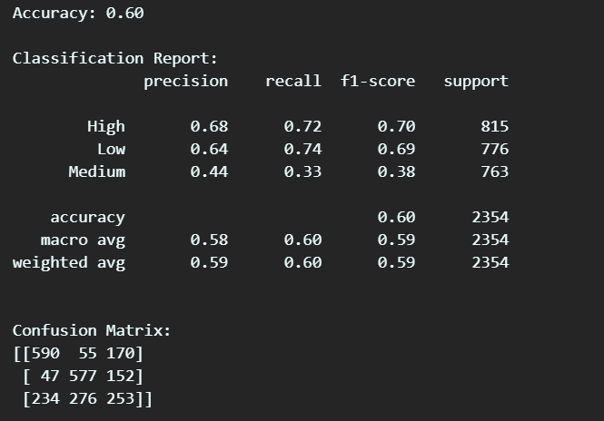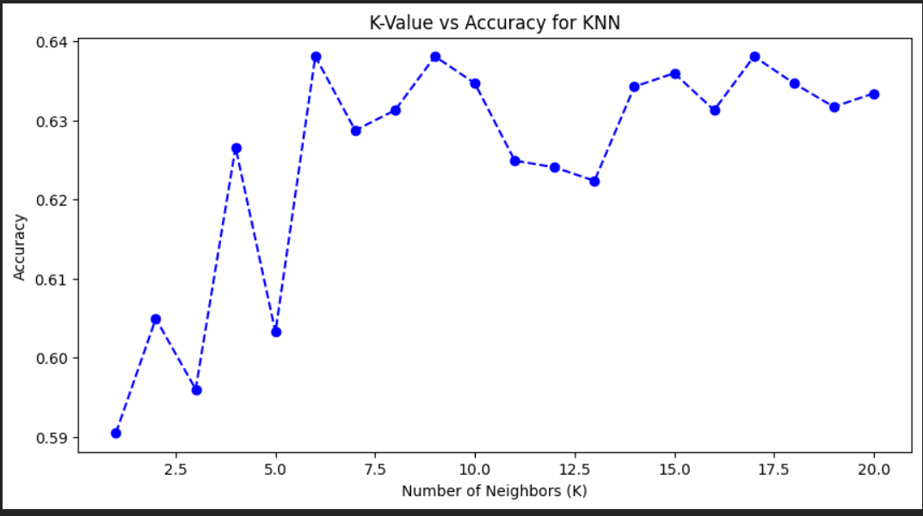

**Q4 ) SVM**

**Weka**

**Output:**

**R Programming**

Code :

# Load required libraries

if (!require("tidyverse")) install.packages("tidyverse", dependencies = TRUE)

if (!require("e1071")) install.packages("e1071") # SVM

if (!require("caret")) install.packages("caret") # Data Processing

library(tidyverse)

library(e1071)

library(caret)

# Load dataset

file_path <- "C:/Users/Sanjay/Desktop/ML Tutorial/archive/laptop_prices.csv"

df <- read.csv(file_path, stringsAsFactors = FALSE)

# Step 1: Fix Column Names

colnames(df) <- gsub("\\.", "_", colnames(df)) # Replace dots with underscores

colnames(df) <- gsub(" ", "_", colnames(df)) # Replace spaces with underscores

# Step 2: Identify the Correct 'Price' Column

price_col <- grep("Price", colnames(df), value = TRUE)

if (length(price_col) == 0) stop("Error: 'Price' column not found in dataset!")

cat("Found Price Column:", price_col, "\n")

colnames(df)[colnames(df) == price_col] <- "Price" # Rename to 'Price'

# Step 3: Convert Storage to Numeric

df$Storage <- as.numeric(gsub("[^0-9]", "", df$Storage))

# Step 4: Convert Resolution to Total Pixels

if ("Resolution" %in% colnames(df)) {

resolution_split <- strsplit(as.character(df$Resolution), "x")

df$Total_Pixels <- sapply(resolution_split, function(x) as.numeric(x[1]) * as.numeric(x[2]))

df <- df %>% select(-Resolution) # Remove Resolution column

}

# Step 5: Handle Missing Values

df <- df %>% drop_na(Brand, Processor, GPU, Operating_System, Price)

# Step 6: Encode Categorical Variables as Factors

df$Brand <- as.factor(df$Brand)

df$Processor <- as.factor(df$Processor)

df$GPU <- as.factor(df$GPU)

df$Operating_System <- as.factor(df$Operating_System)

# Step 7: Convert Price into Categories (Low, Medium, High)

df$Price_Category <- cut(df$Price,

breaks = quantile(df$Price, probs = seq(0, 1, by = 1/3), na.rm = TRUE),

labels = c("Low", "Medium", "High"),

include.lowest = TRUE)

# Step 8: Remove NA Rows

df <- na.omit(df)

# Step 9: Convert Categorical Variables to Numeric using One-Hot Encoding

df_numeric <- model.matrix(~ . - 1, data = df %>% select(-Price_Category)) %>% as.data.frame()

# Step 10: Define Features (X) and Target Variable (y)

X <- df_numeric

y <- df$Price_Category

# Step 11: Normalize Features (Fixing colMeans error)

X_scaled <- scale(X) # Ensures all columns are numeric before scaling

# Step 12: Split Data (80-20)

set.seed(42)

train_indices <- createDataPartition(y, p = 0.8, list = FALSE)

X_train <- X_scaled[train_indices, ]

X_test <- X_scaled[-train_indices, ]

train_labels <- y[train_indices]

test_labels <- y[-train_indices]

# Step 13: Train SVM Model

svm_model <- svm(train_labels ~ ., data = X_train, kernel = "linear", cost = 1)

# Step 14: Make Predictions

svm_pred <- predict(svm_model, X_test)

# Step 15: Evaluate Model Performance

accuracy <- mean(svm_pred == test_labels) * 100

cat("SVM Model Accuracy:", round(accuracy, 2), "%\n")

# Step 16: Confusion Matrix

conf_matrix <- confusionMatrix(as.factor(svm_pred), as.factor(test_labels))

print(conf_matrix)

**Output:**

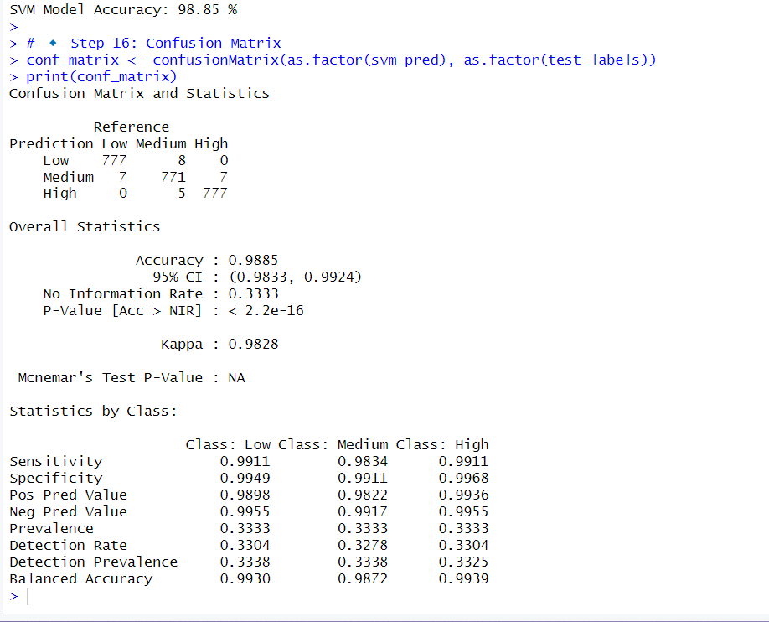

**Python**

**Code :**

*import* pandas *as* pd

*import* numpy *as* np

*import* matplotlib.pyplot *as* plt

*from* sklearn.model_selection *import* train_test_split

*from* sklearn.preprocessing *import* LabelEncoder, StandardScaler

*from* sklearn.svm *import* SVC

*from* sklearn.metrics *import* accuracy_score, classification_report, confusion_matrix

*# Load dataset*

file_path = *r*"C:\Users\Sanjay\Desktop\ML Tutorial\archive\laptop_prices.csv"

df = pd.read_csv(file_path)

*# Convert Storage to numerical format (handling missing values)*

df['Storage'] = df['Storage'].str.extract(*r*'(\d+)').dropna().astype(float)

*# Convert Resolution to total pixel count*

df[['Width', 'Height']] = df['Resolution'].str.split('x', expand=True).astype(float)

df['Total_Pixels'] = df['Width'] * df['Height']

df.drop(columns=['Resolution', 'Width', 'Height'], inplace=True)

*# Encode categorical variables*

label_encoders = {}

*for* col *in* ['Brand', 'Processor', 'GPU', 'Operating System']:

    le = LabelEncoder()

    df[col] = le.fit_transform(df[col])

    label_encoders[col] = le

*# Convert price into categories (Low, Medium, High)*

df['Price Category'] = pd.qcut(df['Price ($)'], q=3, labels=['Low', 'Medium', 'High'])

*# Define features and target variable*

X = df.drop(columns=['Price ($)', 'Price Category'])

y = df['Price Category']

*# Standardize features*

scaler = StandardScaler()

X_scaled = scaler.fit_transform(X)

*# Split dataset into training and testing sets*

X_train, X_test, y_train, y_test = train_test_split(X_scaled, y, test_size=0.2, random_state=42)

*# Train Support Vector Machine (SVM) Classifier*

svm_model = SVC(kernel='linear', C=1.0)  *# Linear Kernel*

svm_model.fit(X_train, y_train)

*# Predictions*

y_pred = svm_model.predict(X_test)

*# Evaluate the model*

accuracy = accuracy_score(y_test, y_pred)

print(*f*"Accuracy: {accuracy*:.2f*}")

print("\nClassification Report:")

print(classification_report(y_test, y_pred))

*# Confusion matrix*

conf_matrix = confusion_matrix(y_test, y_pred)

print("\nConfusion Matrix:")

print(conf_matrix)

*# Visualization (Only for 2D data, choosing first two features)*

plt.figure(figsize=(8, 6))

plt.scatter(X_train[:, 0], X_train[:, 1], c=y_train.astype('category').cat.codes, cmap='coolwarm', edgecolors='k')

plt.xlabel("Feature 1")

plt.ylabel("Feature 2")

plt.title("SVM Decision Boundary (Only 2 Features Visualized)")

plt.show()

**Output :**

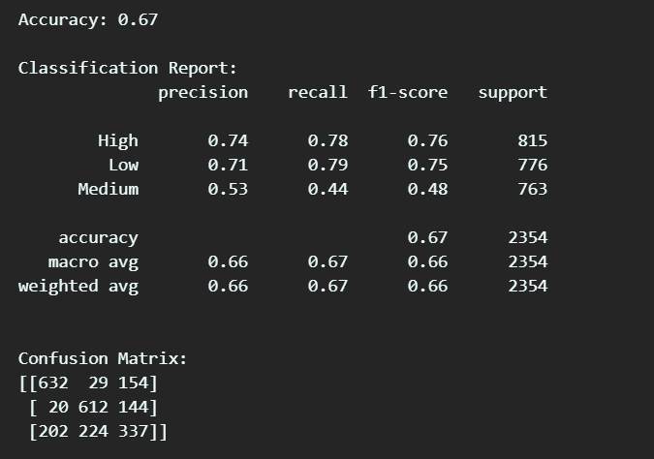

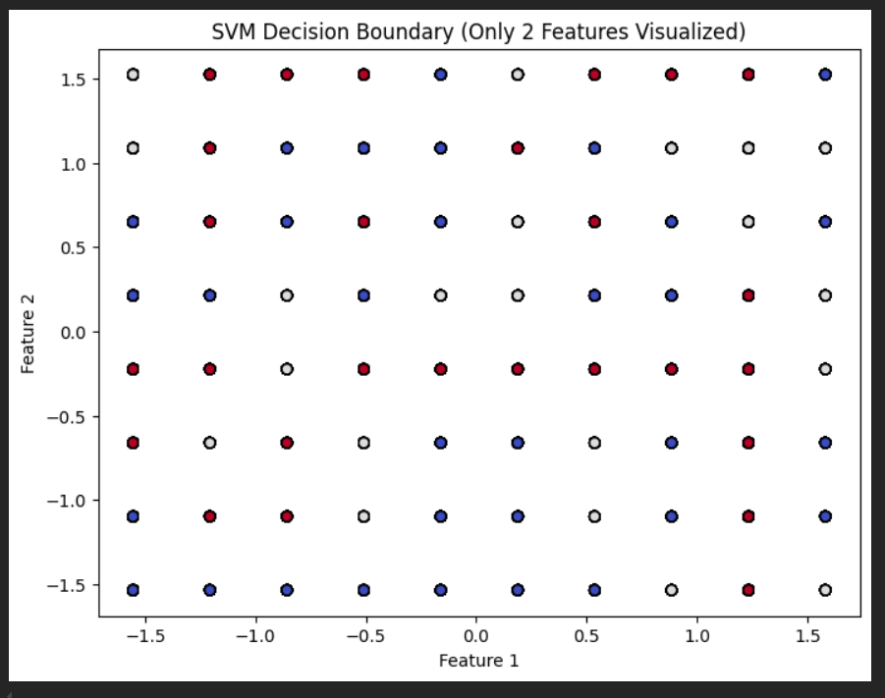

**Q5 ) Kmeans**

**Weka**

**Output:**

**R Programming**

Code :

# Load required libraries

library(dplyr)

library(ggplot2)

library(cluster)

library(factoextra)

library(NbClust)

library(readr)

library(tidyr)

# Load dataset

file_path <- "C:/Users/Sanjay/Desktop/ML Tutorial/archive/laptop_prices.csv"

df <- read_csv(file_path)

# Print column names for reference

print(colnames(df))

# Detect the "Price" column dynamically

price_col <- grep("price", tolower(gsub("[^a-zA-Z0-9]", "", colnames(df))), value = TRUE)

# Ensure the Price column exists

if (length(price_col) == 0) {

stop(" Error: 'Price' column not found in dataset! Check column names above.")

} else {

cat(" Found Price column:", price_col, "\n")

}

# Drop Price column

df <- df %>% select(-matches(price_col))

# Convert Storage to numeric (extract numbers safely)

if ("Storage" %in% colnames(df)) {

df <- df %>%

mutate(Storage = as.numeric(gsub("[^0-9]", "", Storage)))

}

# Convert Resolution to pixel count (handle missing values)

if ("Resolution" %in% colnames(df)) {

df <- df %>%

separate(Resolution, into = c("Width", "Height"), sep = "x", convert = TRUE, fill = "right") %>%

mutate(Total_Pixels = as.numeric(Width) * as.numeric(Height)) %>%

select(-Width, -Height)

}

# Identify categorical columns dynamically

categorical_cols <- c("Brand", "Processor", "GPU", "Operating System")

categorical_cols <- categorical_cols[categorical_cols %in% colnames(df)]

# Convert categorical columns to factors

if (length(categorical_cols) > 0) {

df[categorical_cols] <- lapply(df[categorical_cols], as.factor)

}

# Handle missing values

df <- df %>%

mutate(across(where(is.numeric), ~ ifelse(is.na(.), median(., na.rm = TRUE), .)))

# Convert NaN and Inf values to NA, then replace with median

df <- df %>%

mutate(across(where(is.numeric), ~ ifelse(is.nan(.), NA, .))) %>%

mutate(across(where(is.numeric), ~ ifelse(is.infinite(.), NA, .)))

# Final missing value check

df <- df %>%

mutate(across(where(is.numeric), ~ ifelse(is.na(.), median(., na.rm = TRUE), .)))

# Ensure no NA/NaN/Inf remains

if (any(is.na(df))) stop(" Error: NA values still exist in the dataset after preprocessing!")

if (any(is.nan(as.matrix(df %>% select(where(is.numeric)))))) stop(" Error: NaN values detected!")

if (any(!is.finite(as.matrix(df %>% select(where(is.numeric)))))) stop(" Error: Inf values detected!")

# Remove categorical columns before clustering

df <- df %>% select(where(is.numeric))

# Standardize numeric features

df <- scale(df)

# Find optimal K using the Elbow Method

wss <- sapply(1:10, function(k) {

kmeans(df, centers = k, nstart = 10)$tot.withinss

})

# Plot Elbow Method graph

plot(1:10, wss, type = "b", pch = 19, col = "blue",

xlab = "Number of Clusters (K)", ylab = "Total Within Sum of Squares",

main = "Elbow Method for Optimal K")

# Choose optimal K

optimal_k <- 3

# Apply K-Means clustering

set.seed(42)

kmeans_model <- kmeans(df, centers = optimal_k, nstart = 10)

# Add cluster labels

df_clustered <- as.data.frame(df)

df_clustered$Cluster <- as.factor(kmeans_model$cluster)

# PCA for visualization

pca_result <- prcomp(df, center = TRUE, scale. = TRUE)

df_pca <- as.data.frame(pca_result$x[, 1:2])

df_pca$Cluster <- df_clustered$Cluster

# Scatter plot of clusters

ggplot(df_pca, aes(x = PC1, y = PC2, color = Cluster)) +

geom_point(size = 3) +

labs(title = paste("K-Means Clustering (K =", optimal_k, ") Visualization"),

x = "Principal Component 1", y = "Principal Component 2") +

theme_minimal()

**Output:**

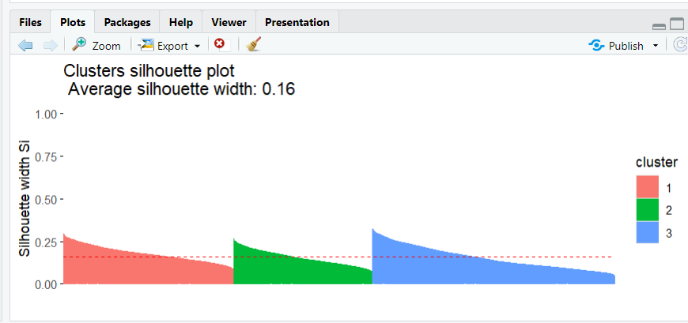

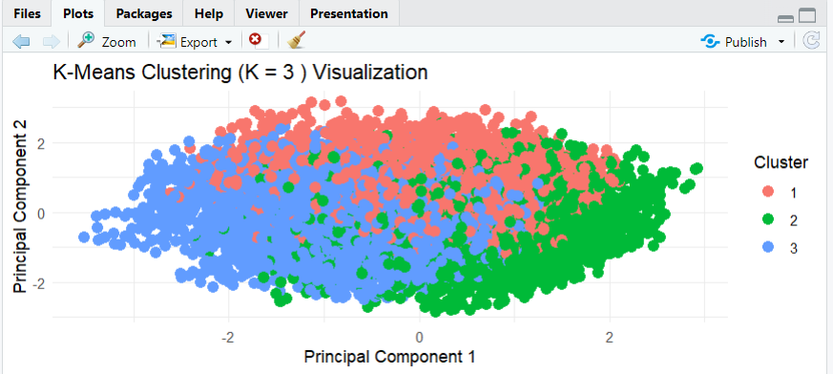

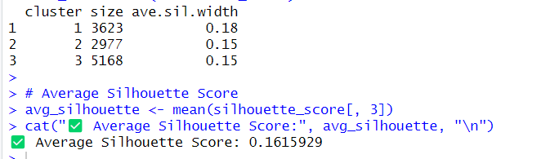

**Python**

**Code :**

*import* pandas *as* pd

*import* numpy *as* np

*import* matplotlib.pyplot *as* plt

*from* sklearn.model_selection *import* train_test_split

*from* sklearn.preprocessing *import* LabelEncoder, StandardScaler

*from* sklearn.cluster *import* KMeans

*from* sklearn.decomposition *import* PCA

*from* sklearn.metrics *import* silhouette_score, davies_bouldin_score, calinski_harabasz_score

*from* sklearn.utils *import* resample

*# Load dataset*

file_path = *r*"C:\Users\Sanjay\Desktop\ML Tutorial\archive\laptop_prices.csv"

df = pd.read_csv(file_path)

*# Convert Storage to numerical format (handling missing values)*

df['Storage'] = df['Storage'].str.extract(*r*'(\d+)').dropna().astype(float)

*# Convert Resolution to total pixel count*

df[['Width', 'Height']] = df['Resolution'].str.split('x', expand=True).astype(float)

df['Total_Pixels'] = df['Width'] * df['Height']

df.drop(columns=['Resolution', 'Width', 'Height'], inplace=True)

*# Encode categorical variables*

label_encoders = {}

*for* col *in* ['Brand', 'Processor', 'GPU', 'Operating System']:

    le = LabelEncoder()

    df[col] = le.fit_transform(df[col])

    label_encoders[col] = le

*# Define features for clustering (excluding price)*

X = df.drop(columns=['Price ($)'])

*# Standardize features*

scaler = StandardScaler()

X_scaled = scaler.fit_transform(X)

*# Find optimal K using Elbow Method*

inertia = []

K_range = range(1, 11)  *# Checking K values from 1 to 10*

*for* k *in* K_range:

    kmeans = KMeans(n_clusters=k, random_state=42, n_init=10)

    kmeans.fit(X_scaled)

    inertia.append(kmeans.inertia_)

*# Plot Elbow Method graph*

plt.figure(figsize=(8, 5))

plt.plot(K_range, inertia, marker='o', linestyle='--', color='b')

plt.xlabel("Number of Clusters (K)")

plt.ylabel("Inertia (Within-Cluster Sum of Squares)")

plt.title("Elbow Method for Optimal K")

plt.show()

*# Train K-Means model with optimal K (choose K based on elbow graph, e.g., 3)*

optimal_k = 3

kmeans = KMeans(n_clusters=optimal_k, random_state=42, n_init=10)

df['Cluster'] = kmeans.fit_predict(X_scaled)

*# Take a random sample to avoid MemoryError*

sample_size = min(10000, len(X_scaled))  *# Ensure it doesn't exceed dataset size*

X_sample, labels_sample = resample(X_scaled, df['Cluster'], n_samples=sample_size, random_state=42)

*# Evaluate Clustering Performance*

silhouette_avg = silhouette_score(X_sample, labels_sample)

davies_bouldin = davies_bouldin_score(X_sample, labels_sample)

calinski_harabasz = calinski_harabasz_score(X_sample, labels_sample)

*# Print evaluation metrics*

print("===== Final Clustering Metrics =====")

print(*f*"Silhouette Score: {silhouette_avg*:.4f*} (Higher is better)")

print(*f*"Davies-Bouldin Index: {davies_bouldin*:.4f*} (Lower is better)")

print(*f*"Calinski-Harabasz Index: {calinski_harabasz*:.4f*} (Higher is better)")

*# Reduce dimensionality for visualization using PCA*

pca = PCA(n_components=2)

X_pca = pca.fit_transform(X_scaled)

*# Scatter plot of clusters*

plt.figure(figsize=(8, 6))

plt.scatter(X_pca[:, 0], X_pca[:, 1], c=df['Cluster'], cmap='viridis', edgecolors='k')

plt.xlabel("PCA Feature 1")

plt.ylabel("PCA Feature 2")

plt.title(*f*"K-Means Clustering (K={optimal_k}) Visualization")

plt.colorbar(label="Cluster")

plt.show()

**Output:** 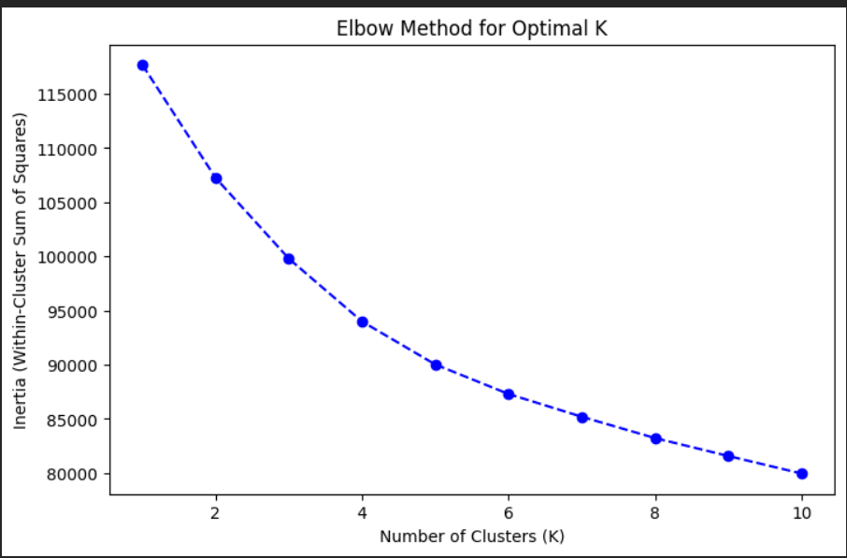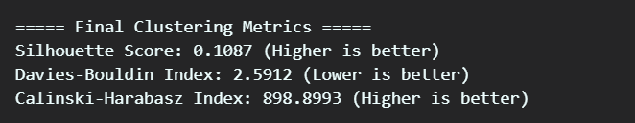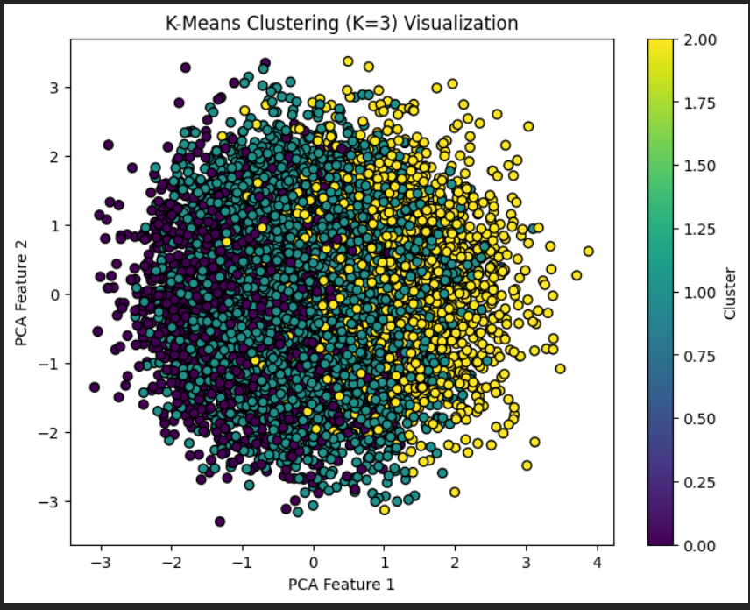

**Q6 ) RandomForest**

**Weka**

**Output:**

**R Programming**

Code :

# Load necessary libraries

if (!require(randomForest)) install.packages("randomForest", dependencies=TRUE)

if (!require(ggplot2)) install.packages("ggplot2", dependencies=TRUE)

if (!require(caret)) install.packages("caret", dependencies=TRUE)

if (!require(dplyr)) install.packages("dplyr", dependencies=TRUE)

library(randomForest)

library(ggplot2)

library(caret)

library(dplyr)

# Load dataset

file_path <- "C:/Users/Sanjay/Desktop/ML Tutorial/archive/laptop_prices.csv"

df <- read.csv(file_path, stringsAsFactors = FALSE)

# Convert Storage to numerical format (handling missing values)

df$Storage <- as.numeric(gsub("\\D", "", df$Storage))

# Convert Resolution to total pixel count

resolution_split <- strsplit(df$Resolution, "x")

df$Width <- as.numeric(sapply(resolution_split, `[`, 1))

df$Height <- as.numeric(sapply(resolution_split, `[`, 2))

df$Total_Pixels <- df$Width * df$Height

df <- df %>% select(-Resolution, -Width, -Height)

# Encode categorical variables

categorical_cols <- c("Brand", "Processor", "GPU", "Operating.System")

df[categorical_cols] <- lapply(df[categorical_cols], as.factor)

# Define features and target variable

target <- "Price...."

X <- df %>% select(-all_of(target))

y <- df[[target]]

# Split dataset into training and testing sets

set.seed(42)

train_indices <- createDataPartition(y, p = 0.8, list = FALSE)

train_data <- df[train_indices, ]

test_data <- df[-train_indices, ]

# Train Random Forest Regressor

rf_model <- randomForest(Price.... ~ ., data = train_data, ntree = 100, importance = TRUE, seed = 42)

# Predictions

rf_pred <- predict(rf_model, test_data)

# Evaluate the model

mae <- mean(abs(test_data$Price.... - rf_pred))

mse <- mean((test_data$Price.... - rf_pred)^2)

rmse <- sqrt(mse)

r2 <- cor(test_data$Price...., rf_pred)^2

# Compute Adjusted R²

n <- nrow(test_data) # Number of test samples

p <- ncol(test_data) - 1 # Number of features

adjusted_r2 <- 1 - (1 - r2) * (n - 1) / (n - p - 1)

# Print accuracy metrics

data.frame(

Metric = c("Mean Absolute Error", "Mean Squared Error", "Root Mean Squared Error", "R² Score", "Adjusted R² Score", "Final Accuracy (R² Score)"),

Value = c(round(mae, 2), round(mse, 2), round(rmse, 2), round(r2, 4), round(adjusted_r2, 4), round(r2 * 100, 2))

)

# Feature Importance Visualization

importance_df <- as.data.frame(importance(rf_model))

importance_df$Feature <- rownames(importance_df)

importance_df <- importance_df %>% arrange(desc(IncNodePurity))

ggplot(importance_df, aes(x = reorder(Feature, IncNodePurity), y = IncNodePurity)) +

geom_bar(stat = "identity", fill = "steelblue") +

coord_flip() +

labs(title = "Feature Importance in Random Forest", x = "Feature", y = "Importance") +

theme_minimal()

**Output:**

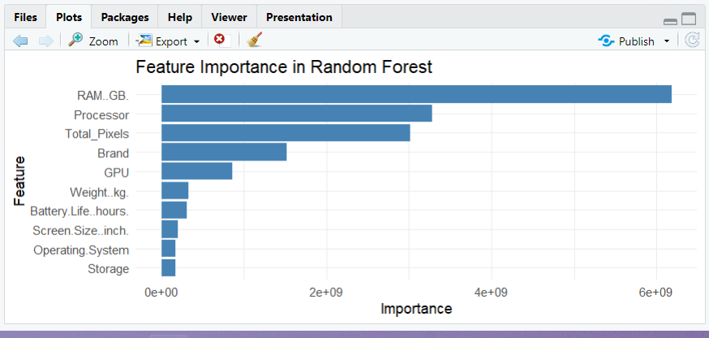

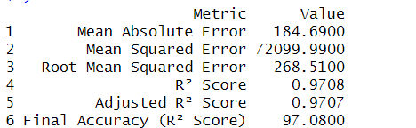

**Python**

**Code :**

*import* pandas *as* pd

*import* numpy *as* np

*import* matplotlib.pyplot *as* plt

*from* sklearn.model_selection *import* train_test_split

*from* sklearn.preprocessing *import* LabelEncoder

*from* sklearn.ensemble *import* RandomForestRegressor

*from* sklearn.metrics *import* mean_absolute_error, mean_squared_error, r2_score

*# Load dataset*

file_path = *r*"C:\Users\Sanjay\Desktop\ML Tutorial\archive\laptop_prices.csv"

df = pd.read_csv(file_path)

*# Convert Storage to numerical format (handling missing values)*

df['Storage'] = df['Storage'].str.extract(*r*'(\d+)').dropna().astype(float)

*# Convert Resolution to total pixel count*

df[['Width', 'Height']] = df['Resolution'].str.split('x', expand=True).astype(float)

df['Total_Pixels'] = df['Width'] * df['Height']

df.drop(columns=['Resolution', 'Width', 'Height'], inplace=True)

*# Encode categorical variables*

label_encoders = {}

*for* col *in* ['Brand', 'Processor', 'GPU', 'Operating System']:

    le = LabelEncoder()

    df[col] = le.fit_transform(df[col])

    label_encoders[col] = le

*# Define features and target variable*

X = df.drop(columns=['Price ($)'])

y = df['Price ($)']

*# Split dataset into training and testing sets*

X_train, X_test, y_train, y_test = train_test_split(X, y, test_size=0.2, random_state=42)

*# Train Random Forest Regressor*

rf_model = RandomForestRegressor(n_estimators=100, random_state=42)

rf_model.fit(X_train, y_train)

*# Predictions*

y_pred = rf_model.predict(X_test)

*# Evaluate the model*

mae = mean_absolute_error(y_test, y_pred)

mse = mean_squared_error(y_test, y_pred)

rmse = np.sqrt(mse)

r2 = r2_score(y_test, y_pred)

*# Compute Adjusted R²*

n = X_test.shape[0]  *# Number of test samples*

p = X_test.shape[1]  *# Number of features*

adjusted_r2 = 1 - (1 - r2) * (n - 1) / (n - p - 1)

*# Print accuracy metrics*

print("=== Model Performance ===")

print(*f*"Mean Absolute Error (MAE): {mae*:.2f*}")

print(*f*"Mean Squared Error (MSE): {mse*:.2f*}")

print(*f*"Root Mean Squared Error (RMSE): {rmse*:.2f*}")

print(*f*"R² Score: {r2*:.4f*}")

print(*f*"Adjusted R² Score: {adjusted_r2*:.4f*}")

print(*f*"Final Accuracy (R² Score): {r2 * 100*:.2f*}%")

*# Feature Importance Visualization*

feature_importances = rf_model.feature_importances_

sorted_indices = np.argsort(feature_importances)[::-1]

plt.figure(figsize=(10, 6))

plt.bar(range(X.shape[1]), feature_importances[sorted_indices], align="center")

plt.xticks(range(X.shape[1]), X.columns[sorted_indices], rotation=90)

plt.xlabel("Feature")

plt.ylabel("Importance")

plt.title("Feature Importance in Random Forest")

plt.show()

**Output:**

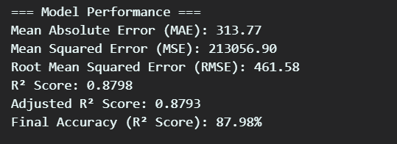

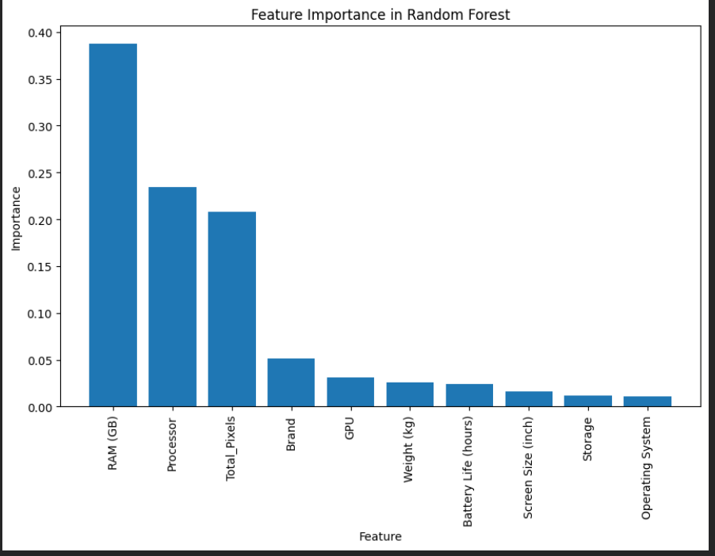

**Q7 ) Algoritham**

**Weka**

Code :

Output:

**R Programming**

**Code :**

library(xgboost)

library(caret)

file_path <- "C:/Users/Sanjay/Desktop/ML Tutorial/archive/laptop_prices.csv"

df <- read.csv(file_path)

df$Storage <- as.numeric(gsub("\\D", "", df$Storage))

resolution_split <- strsplit(df$Resolution, "x")

df$Width <- as.numeric(sapply(resolution_split, `[`, 1))

df$Height <- as.numeric(sapply(resolution_split, `[`, 2))

df$Total_Pixels <- df$Width * df$Height

df <- df[ , !(names(df) %in% c("Resolution", "Width", "Height"))]

df <- na.omit(df)

df$Brand <- as.numeric(factor(df$Brand))

df$Processor <- as.numeric(factor(df$Processor))

df$GPU <- as.numeric(factor(df$GPU))

df$`Operating.System` <- as.numeric(factor(df$`Operating.System`))

X <- df[, !names(df) %in% c("Price..")]

y <- df$Price..

set.seed(42)

train_index <- createDataPartition(y, p = 0.8, list = FALSE)

X_train <- X[train_index, ]

y_train <- y[train_index]

X_test <- X[-train_index, ]

y_test <- y[-train_index]

dtrain <- xgb.DMatrix(data = as.matrix(X_train), label = y_train)

dtest <- xgb.DMatrix(data = as.matrix(X_test), label = y_test)

param <- list(

objective = "reg:squarederror",

eta = 0.1,

max_depth = 6,

nrounds = 100,

subsample = 0.8,

colsample_bytree = 0.8

)

xgb_model <- xgb.train(params = param, data = dtrain, nrounds = param$nrounds)

predictions <- predict(xgb_model, newdata = dtest)

mse <- mean((y_test - predictions)^2)

r2 <- 1 - sum((y_test - predictions)^2) / sum((y_test - mean(y_test))^2)

cat("MSE:", mse, "\nR² Score:", r2, "\n")

cat("Final Accuracy (R² Score):", r2 * 100, "%\n")

**Output:**

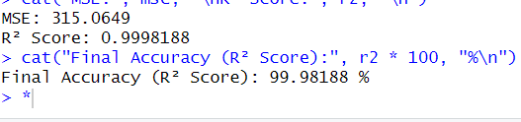

**Python**

**Code :**

*import* pandas *as* pd

*import* numpy *as* np

*import* matplotlib.pyplot *as* plt

*from* sklearn.model_selection *import* train_test_split

*from* sklearn.preprocessing *import* LabelEncoder

*from* sklearn.ensemble *import* AdaBoostRegressor

*from* sklearn.tree *import* DecisionTreeRegressor

*from* sklearn.metrics *import* mean_absolute_error, mean_squared_error, r2_score

*# Load dataset*

file_path = *r*"C:\Users\Sanjay\Desktop\ML Tutorial\archive\laptop_prices.csv"

df = pd.read_csv(file_path)

*# Convert Storage to numerical format (handling missing values)*

df['Storage'] = df['Storage'].str.extract(*r*'(\d+)').dropna().astype(float)

*# Convert Resolution to total pixel count*

df[['Width', 'Height']] = df['Resolution'].str.split('x', expand=True).astype(float)

df['Total_Pixels'] = df['Width'] * df['Height']

df.drop(columns=['Resolution', 'Width', 'Height'], inplace=True)

*# Encode categorical variables*

label_encoders = {}

*for* col *in* ['Brand', 'Processor', 'GPU', 'Operating System']:

    le = LabelEncoder()

    df[col] = le.fit_transform(df[col])

    label_encoders[col] = le

*# Define features and target variable*

X = df.drop(columns=['Price ($)'])

y = df['Price ($)']

*# Split dataset*

X_train, X_test, y_train, y_test = train_test_split(X, y, test_size=0.2, random_state=42)

*# Fix: Use 'estimator' instead of 'base_estimator'*

adaboost_model = AdaBoostRegressor(

    estimator=DecisionTreeRegressor(max_depth=5),  *# Fixed*

    n_estimators=50,

    random_state=42

)

*# Train the model*

adaboost_model.fit(X_train, y_train)

*# Predictions*

y_pred = adaboost_model.predict(X_test)

*# Evaluate the model*

mae = mean_absolute_error(y_test, y_pred)

mse = mean_squared_error(y_test, y_pred)

rmse = np.sqrt(mse)

r2 = r2_score(y_test, y_pred)

*# Compute Adjusted R² Score*

n = X_test.shape[0]  *# Number of test samples*

p = X_test.shape[1]  *# Number of features*

adjusted_r2 = 1 - (1 - r2) * (n - 1) / (n - p - 1)

*# Final Accuracy Results*

print("=== Model Performance ===")

print(*f*"Mean Absolute Error (MAE): {mae*:.2f*}")

print(*f*"Mean Squared Error (MSE): {mse*:.2f*}")

print(*f*"Root Mean Squared Error (RMSE): {rmse*:.2f*}")

print(*f*"R² Score: {r2*:.4f*}")

print(*f*"Adjusted R² Score: {adjusted_r2*:.4f*}")

print(*f*"Final Accuracy (R² Score): {r2 * 100*:.2f*}%")

*# Plot feature importance*

feature_importances = adaboost_model.feature_importances_

sorted_indices = np.argsort(feature_importances)[::-1]

plt.figure(figsize=(10, 6))

plt.bar(range(X.shape[1]), feature_importances[sorted_indices], align="center")

plt.xticks(range(X.shape[1]), X.columns[sorted_indices], rotation=90)

plt.xlabel("Feature")

plt.ylabel("Importance")

plt.title("Feature Importance in AdaBoost")

plt.show()

**Output:**

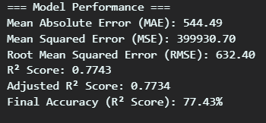

**Q8 ) Stacking**

**Weka**

**Output:**

**R Programming**

**Code** :

library(caret)

library(randomForest)

library(xgboost)

library(e1071)

file_path <- "C:/Users/Sanjay/Desktop/ML Tutorial/archive/laptop_prices.csv"

df <- read.csv(file_path)

df$Storage <- as.numeric(gsub("\\D", "", df$Storage))

resolution_split <- strsplit(df$Resolution, "x")

df$Width <- as.numeric(sapply(resolution_split, `[`, 1))

df$Height <- as.numeric(sapply(resolution_split, `[`, 2))

df$Total_Pixels <- df$Width * df$Height

df <- df[ , !(names(df) %in% c("Resolution", "Width", "Height"))]

df <- na.omit(df)

df$Brand <- as.numeric(factor(df$Brand))

df$Processor <- as.numeric(factor(df$Processor))

df$GPU <- as.numeric(factor(df$GPU))

df$`Operating.System` <- as.numeric(factor(df$`Operating.System`))

X <- df[, !names(df) %in% c("Price..")]

y <- df$Price..

set.seed(42)

train_index <- createDataPartition(y, p = 0.8, list = FALSE)

X_train <- X[train_index, ]

y_train <- y[train_index]

X_test <- X[-train_index, ]

y_test <- y[-train_index]

decision_tree <- train(y_train ~ ., data = cbind(X_train, y_train), method = "rpart", tuneLength = 10)

random_forest <- randomForest(x = X_train, y = y_train, ntree = 10)

dtrain <- xgb.DMatrix(data = as.matrix(X_train), label = y_train)

dtest <- xgb.DMatrix(data = as.matrix(X_test), label = y_test)

param <- list(

objective = "reg:squarederror",

eta = 0.1,

max_depth = 6,

nrounds = 100,

subsample = 0.8,

colsample_bytree = 0.8

)

xgb_model <- xgb.train(params = param, data = dtrain, nrounds = param$nrounds)

meta_train_data <- data.frame(

DT_pred = predict(decision_tree, X_train),

RF_pred = predict(random_forest, X_train),

XGB_pred = predict(xgb_model, newdata = as.matrix(X_train)),

y_train = y_train

)

meta_model <- lm(y_train ~ ., data = meta_train_data)

predict_dt <- predict(decision_tree, X_test)

predict_rf <- predict(random_forest, X_test)

predict_xgb <- predict(xgb_model, newdata = as.matrix(X_test))

meta_test_data <- data.frame(

DT_pred = predict_dt,

RF_pred = predict_rf,

XGB_pred = predict_xgb

)

meta_pred <- predict(meta_model, newdata = meta_test_data)

mse <- mean((y_test - meta_pred)^2)

r2 <- 1 - sum((y_test - meta_pred)^2) / sum((y_test - mean(y_test))^2)

cat("MSE:", mse, "\nR² Score:", r2, "\n")

cat("Final Accuracy (R² Score):", r2 * 100, "%\n")

**Output:**

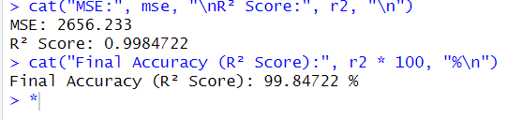

**Python**

**Code :**

*import* pandas *as* pd

*import* numpy *as* np

*import* matplotlib.pyplot *as* plt

*import* seaborn *as* sns

*from* sklearn.model_selection *import* train_test_split

*from* sklearn.preprocessing *import* LabelEncoder

*from* sklearn.ensemble *import* StackingRegressor, RandomForestRegressor, AdaBoostRegressor

*from* sklearn.tree *import* DecisionTreeRegressor

*from* sklearn.linear_model *import* Ridge

*from* sklearn.metrics *import* mean_squared_error, r2_score

*# Load dataset*

file_path = *r*"C:\Users\Sanjay\Desktop\ML Tutorial\archive\laptop_prices.csv"

df = pd.read_csv(file_path)

*# Convert Storage to numerical format*

df['Storage'] = df['Storage'].str.extract(*r*'(\d+)').dropna().astype(float)

*# Convert Resolution to total pixel count*

df[['Width', 'Height']] = df['Resolution'].str.extract(*r*'(\d+)x(\d+)').astype(float)

df['Total_Pixels'] = df['Width'] * df['Height']

df.drop(columns=['Resolution', 'Width', 'Height'], inplace=True)  *# Drop old Resolution column*

*# Encode categorical variables*

*for* col *in* ['Brand', 'Processor', 'GPU', 'Operating System']:

    df[col] = LabelEncoder().fit_transform(df[col])

*# Define features and target*

X = df.drop(columns=['Price ($)'])

y = df['Price ($)']

*# Split dataset*

X_train, X_test, y_train, y_test = train_test_split(X, y, test_size=0.2, random_state=42)

*# Define base models*

base_models = [

    ('decision_tree', DecisionTreeRegressor(max_depth=4)),

    ('random_forest', RandomForestRegressor(n_estimators=10, random_state=42)),

    ('adaboost', AdaBoostRegressor(DecisionTreeRegressor(max_depth=4), n_estimators=10, random_state=42))

]

*# Meta-model*

meta_model = Ridge(alpha=1.0)

*# Stacking Regressor*

stacking_model = StackingRegressor(estimators=base_models, final_estimator=meta_model)

*# Train model*

stacking_model.fit(X_train, y_train)

*# Predictions*

y_pred = stacking_model.predict(X_test)

*# Evaluation*

mse = mean_squared_error(y_test, y_pred)

r2 = r2_score(y_test, y_pred)

print(*f*"MSE: {mse*:.2f*}, R² Score: {r2*:.4f*}")

print(*f*"Final Accuracy (R² Score): {r2 * 100*:.2f*}%")

*# 1. Feature Importance (from Random Forest)*

feature_importances = stacking_model.named_estimators_['random_forest'].feature_importances_

sorted_indices = np.argsort(feature_importances)[::-1]

plt.figure(figsize=(10, 5))

sns.barplot(x=X.columns[sorted_indices], y=feature_importances[sorted_indices], palette="viridis")

plt.xticks(rotation=90)

plt.xlabel("Feature")

plt.ylabel("Importance")

plt.title("Feature Importance in Stacking (Random Forest)")

plt.show()

*# 2. Predicted vs. Actual Prices*

plt.figure(figsize=(8, 6))

sns.scatterplot(x=y_test, y=y_pred, alpha=0.7, color="blue")

plt.plot([y.min(), y.max()], [y.min(), y.max()], 'r--')  *# Ideal prediction line*

plt.xlabel("Actual Price ($)")

plt.ylabel("Predicted Price ($)")

plt.title("Actual vs. Predicted Laptop Prices")

plt.show()

*# 3. Residual Errors Histogram*

residuals = y_test - y_pred

plt.figure(figsize=(8, 5))

sns.histplot(residuals, bins=30, kde=True, color="purple")

plt.axvline(0, color='red', linestyle='dashed')  *# Mean error line*

plt.xlabel("Prediction Error (Residuals)")

plt.ylabel("Frequency")

plt.title("Distribution of Prediction Errors")

plt.show()

**Output:**

